Lesson 4 - Physical Features of Earth
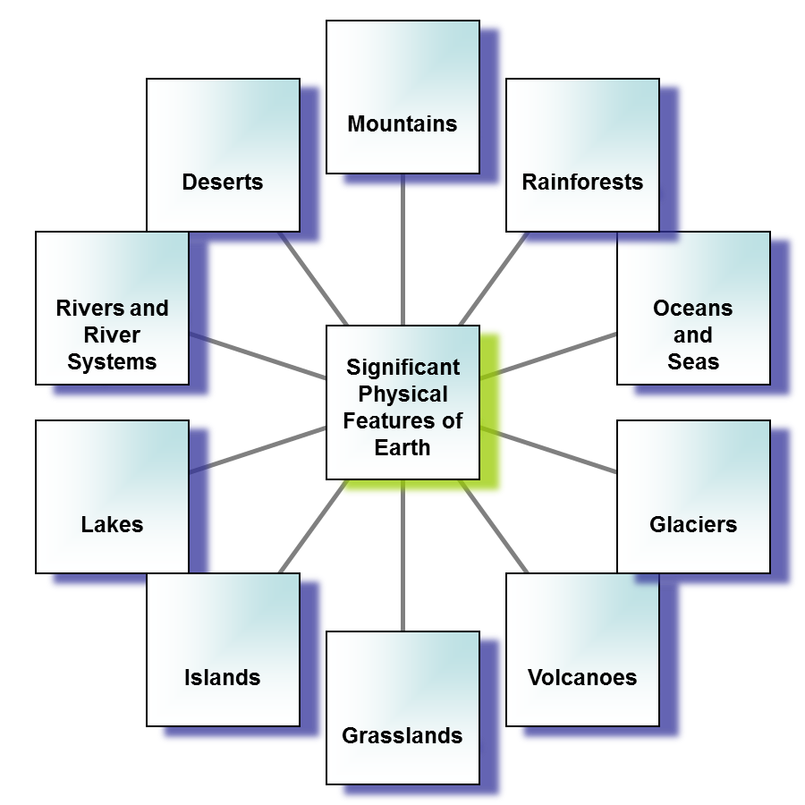

Is there a connection between some physical features and their location to the equator? Why or why not?

_____________________________________________________________________________________________________________________________________________________________________________________________

Considering all the earth’s physical features, which ones seem to be connected?
Where you see… | you may also see… | because …

What physical features are not connected to each other?
Where you see… | you will probably not see… | because …

_{Physical Features of Earth}

Directions: Describe each of the following physical features of Earth.
Use enough details to explain what this physical feature would look like to someone who has never seen it.
Desert

Grassland

Mountain

Rainforest

River Basin

Volcano

