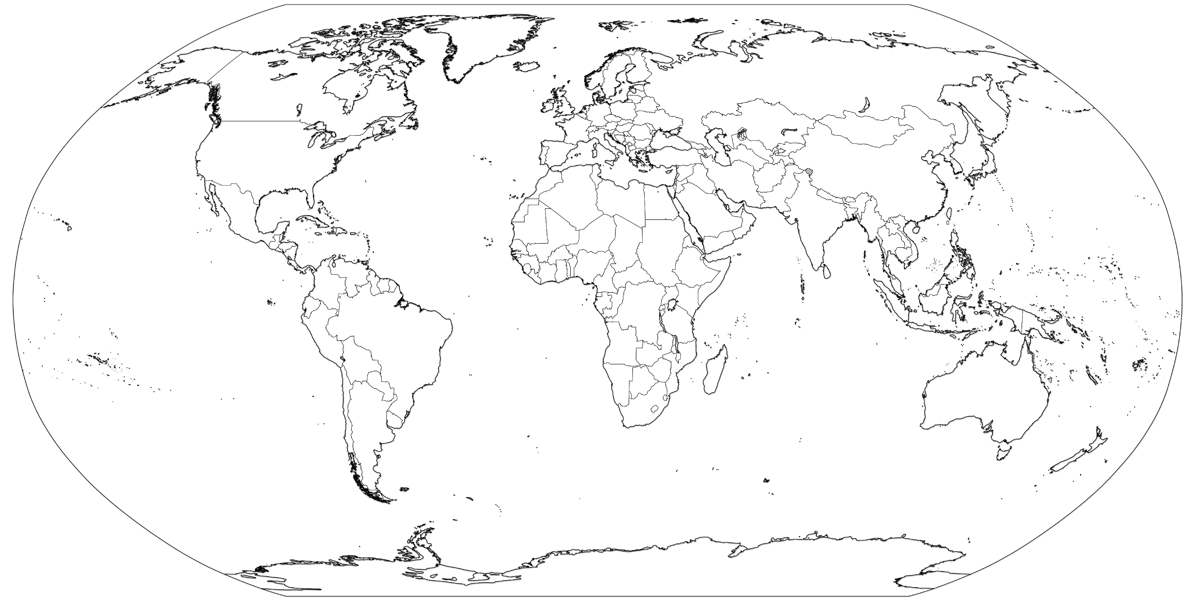

Name: __________ Hr:____

1. Argentina
2. Atlantic Ocean
3. Belize
4. Bering Sea
5. Bolivia
6. Brazil
7. Canada
8. Caribbean Sea
9. Chile
10. Colombia
11. Costa Rica
12. Cuba
13. Dominican Republic
14. Ecuador
15. El Salvador
16. Greenland
17. Guatemala
18. Gulf of Mexico
19. Gulf of St. Lawrence
20. Guyana
21. Haiti
22. Honduras
23. Hudson Bay
24. Jamaica
25. Mexico
26. Nicaragua
27. Pacific Ocean
28. Panama
29. Paraguay
30. Peru
31. Puerto Rico
32. Suriname
33. The Bahamas
34. United States
35. Uruguay
36. Venezuela

­­



1. Afghanistan
2. Algeria
3. Austria
4. Bangladesh
5. Bay of Bengal
6. Belgium
7. Caspian Sea
8. China
9. Cyprus
10. Czech Republic
11. Dem. Rep. Congo
12. Denmark
13. Egypt
14. Ethiopia
15. Finland
16. France
17. Germany
18. Ghana
19. Greece
20. Hungary
21. Iceland
22. India
23. Indian Ocean
24. Indonesia
25. Iran
26. Iraq
27. Ireland
28. Italy
29. Japan
30. Kenya
31. Libya
32. Madagascar
33. Mali
34. Mediterranean Sea
35. Mongolia
36. Mozambique
37. Netherlands
38. Nigeria
39. North Korea
40. Norway
41. Pacific Ocean
42. Pakistan
43. Persian Gulf
44. Philippines
45. Poland
46. Portugal
47. Red Sea
48. Romania
49. Russia
50. Saudi Arabia
51. Senegal
52. Serbia
53. South Africa
54. South China Sea
55. South Korea
56. Spain
57. Sudan
58. Sweden
59. Switzerland
60. Syria
61. Tanzania
62. Turkey
63. Ukraine
64. United Kingdom